

Foundations of Programming
Name-SARANSH PARIHAR
PRN-1262253066(DIV-11)(CSE-AIDS)

Lab Assignment No. : 02

PROBLEM STATEMENT:
Write a menu driven program in C to implement the basic arithmetic operations such as Addition, Subtraction, Multiplication, and Division.

OBJECTIVES:
• To understand the concept of menu driven programming in C.
• To apply conditional statements and switch–case control structures.
• To perform basic arithmetic operations using user-defined input.
• To enhance logical thinking and problem-solving skills.

THEORY:
if–else ladder statements syntax and sample program
switch–case or if–else ladder statement syntax and sample progrM
Basic arithmetic operations include Addition, Subtraction, Multiplication, and Division. Division by zero should be avoided.

ALGORITHM:

Type Program

PLATFORM:
Linux

INPUT:
Choice of operation and two numbers

OUTPUT:
Displays the result of the selected arithmetic operation

SAMPLE INPUT:
1
10 5

SAMPLE OUTPUT:
Addition = 15

CONCLUSION:
Thus, the menu driven program in C successfully performs basic arithmetic operations using switch–case statements.

FAQs:
1. What is a menu driven program?
2. Why is switch–case preferred over if–else ladder in menu driven programs?
3. What is the purpose of the break statement in switch–case?
4. What is the purpose of the break statement in switch–case?
5. What are the limitations of switch–case compared to if–else?

Code:
#include <stdio.h>
int main(){
int a;
int b;
int op;
printf("Enter the value of 'a' : ");
scanf("%d",&a);
printf("Enter the value of 'b' : ");
scanf("%d",&b);

printf("Enter the Operator number from the following : \n");
printf("1.Addition.\n");
printf("2.Subtraction.\n");
printf("3.Multiplication.\n");
printf("4.Division.\n");
scanf("%d",&op);
if(op==1){
printf("The Addition of 'a' and 'b' is : %d ",a+b);
}
else if(op==2){
printf("The Subtraction of 'a' and 'b' is : %d ",a-b);
}
else if(op==3){
printf("The Multiplication of 'a' and 'b' is : %d ",a*b);
}
else if(op==4){
printf("The Division of 'a' and 'b' is : %d ",a/b);
}
else{
printf("Invalid Option");
}
}

Code screenshot:
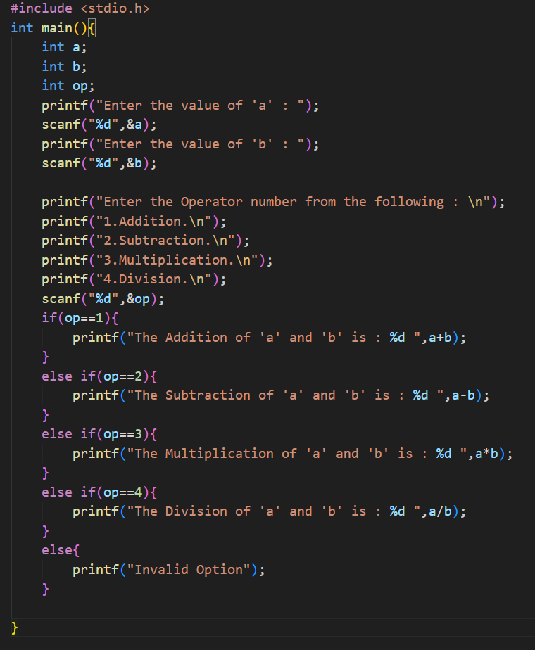
Output screenshot: 